Concept Jordi van der Hulst

**Limbo Dancer**

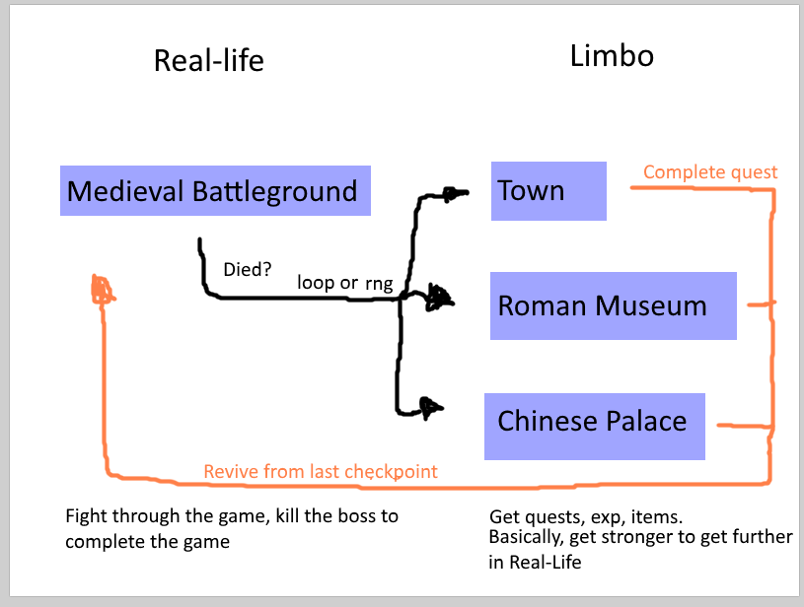

You start as a soldier during war in de medieval battleground. The first enemies are easy but after the first checkpoint it will get REALLY hard. Enemies will kill you eventually, you’ll go to Limbo to one of the three alternate universes. You can explore that area and find the quest. If you complete it you’ll get items/exp/other stats and then revive to the last checkpoint of the medieval battleground. The game will then be easy again till you reach the next checkpoint… etc…